**스프로그래밍**

**과제(10/16)**

과목명: 프로그래밍

과제 제목: 과제(10/16)

작성자 학번: 2018156047 (쯔엉 수안 즈엉)

작성일: 2020/10/22

**135.2**

**135.3**

**150.2**

**150.3**

**165.1**

**165.2**

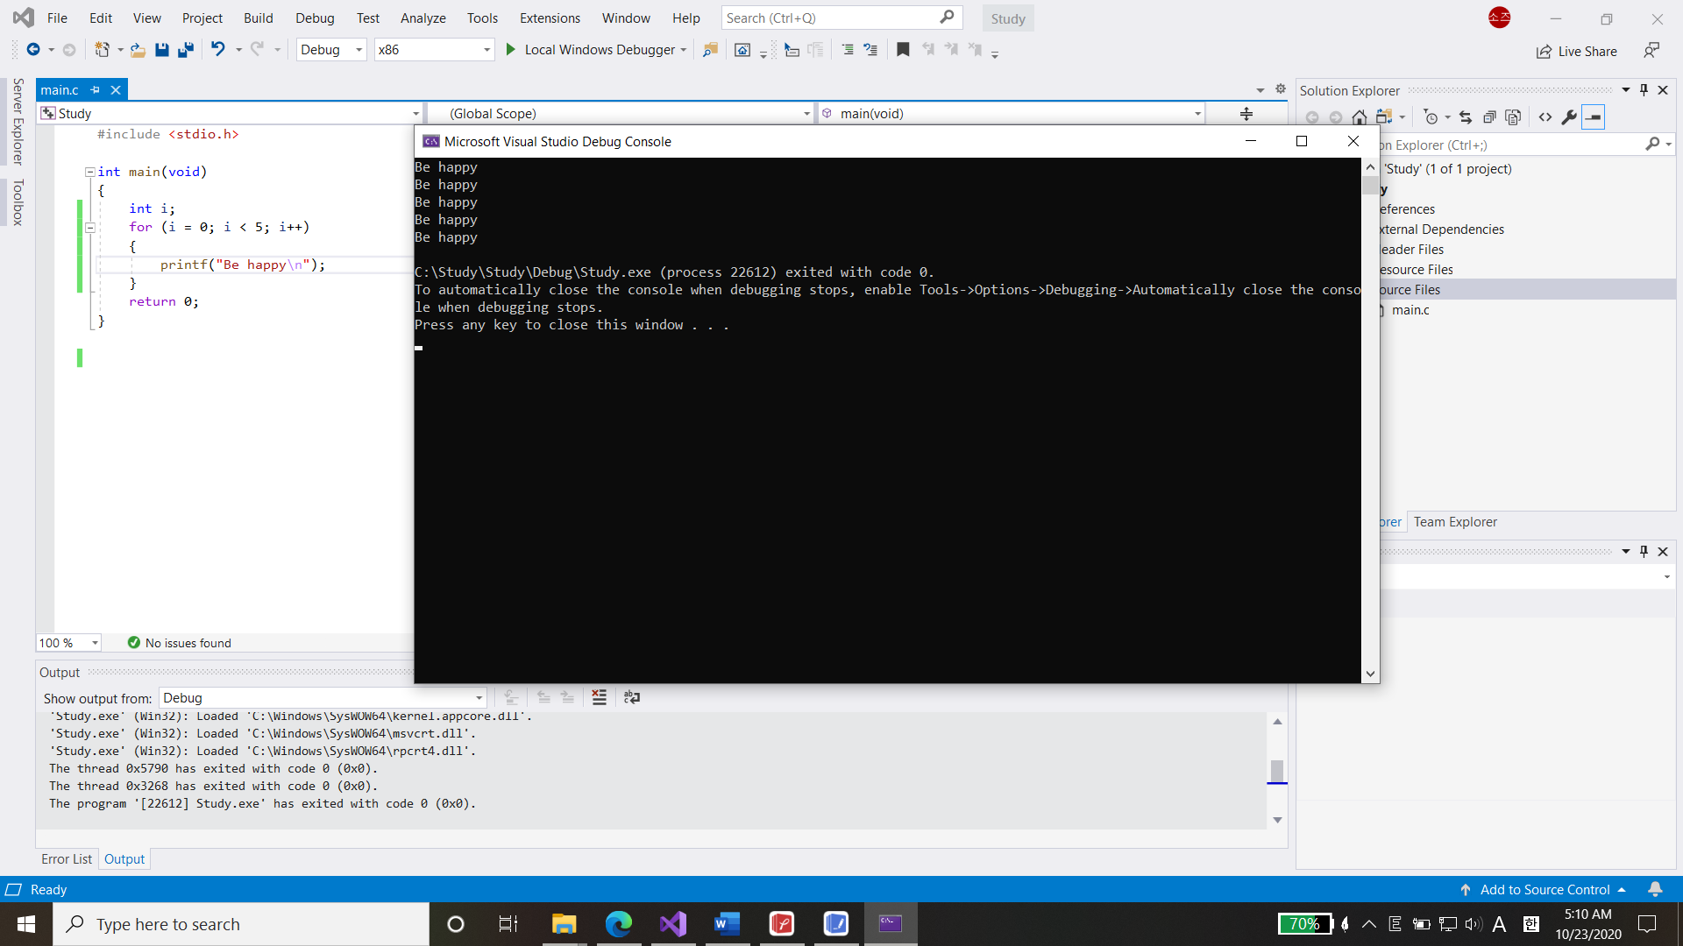

**165.3**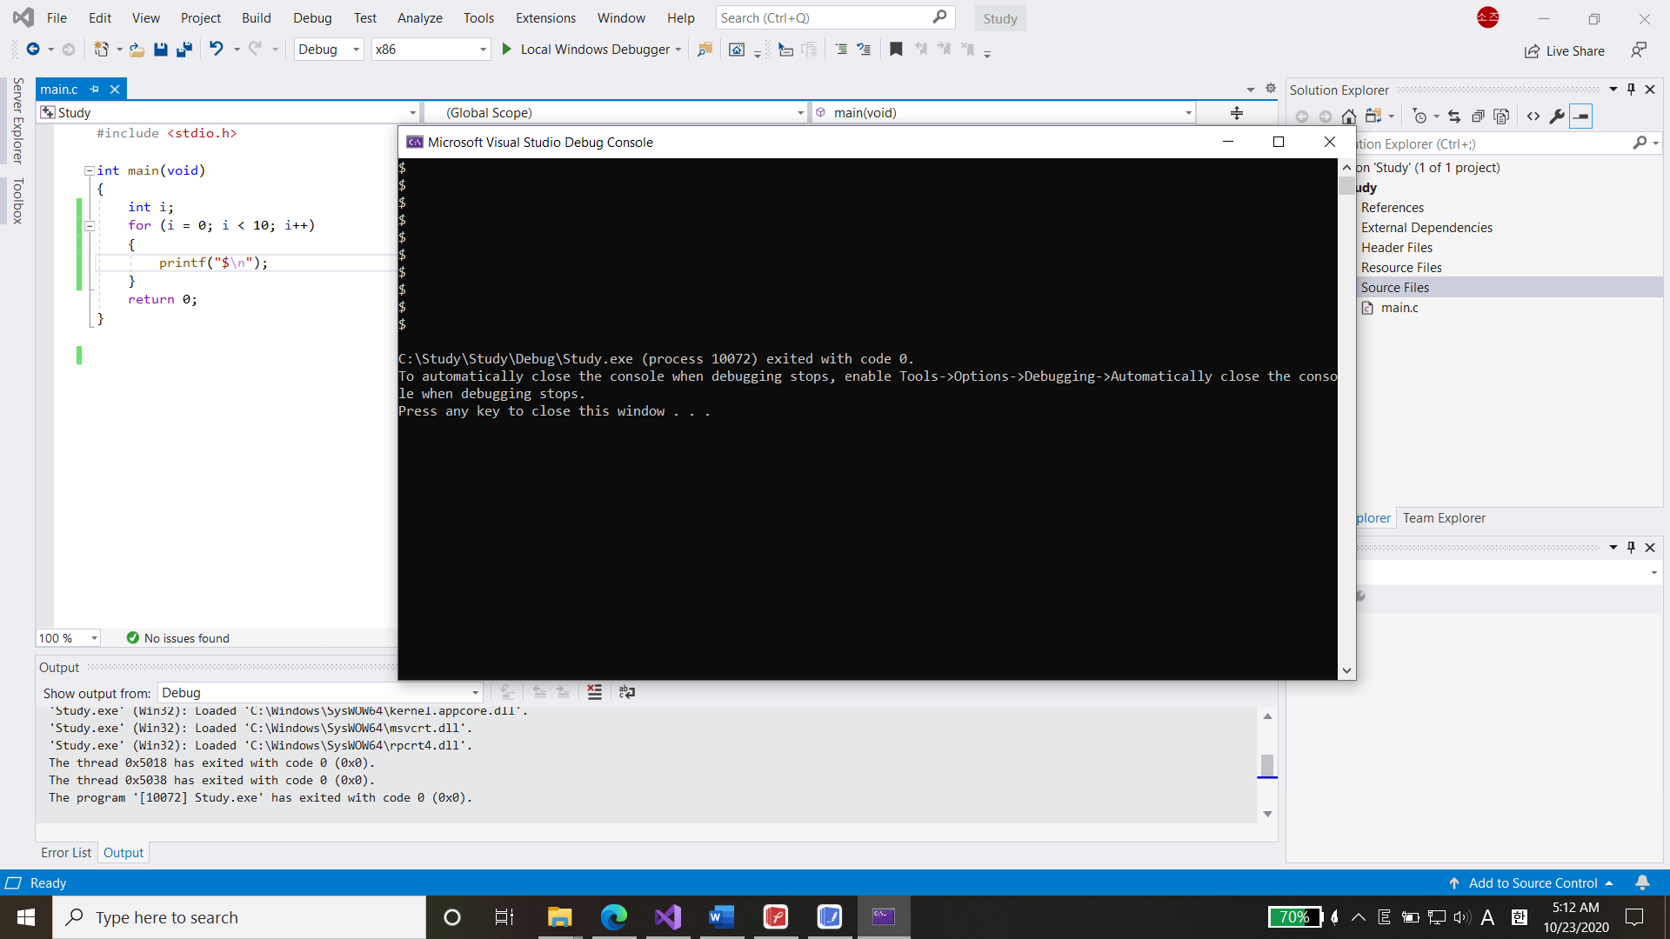

**감사합니다**